MGMS

Architecture Design Document

Ver. 1.4

Version History
Date | Description
24-Oct-2010 | First Draft

Table of Contents

Version History 2
1 Introduction 4
1.1 System Objective 4
1.2 Purpose & Scope 4
1.3 Scope 4
2 High Level Design 5
2.1 Need of Architecture Design 5
2.2 MVC Architecture (3 tier / n tier architecture) 5
2.3 System Architecture 6
2.3.1 Rich Internet Application - Basics 7
2.4 Work flows in MGMS: 8
2.4.1 Role based user access flow 8
2.4.2 Admin Work Flow 9
2.4.3 Grantee Work Flow 10
2.4.4 Grantor Work Flow 11
2.5 Architecture of MGMS 12
2.5.1 Groovy on Grails 12
2.5.2 Other technologies: 13

Introduction

System Objective
Main objective of the system is to make an Online Multi site Grant management System for effective grant maintenance and tracking and the aim of maintaining minimal manual records (which will address space constraints).

Purpose & Scope
Purpose of this document is to describe the architecture and design for developing the Online Multi site Grant management System for MHRD that is expected to provide full featured web based online system.

Scope
This document deals with only design-level components. It does not list source code or pseudo-code of the system components.

High Level Design

Need of Architecture Design
Major design decisions of the system are listed as follows;

- Easiness and reuse.
- Highly reliable and scalable.
- Security.
- Use of standards makes easy to develop and maintain.
- Reduce the maintenance cost.

MVC Architecture (3 tier / n tier architecture)
M – Model
V – View
C – Controller
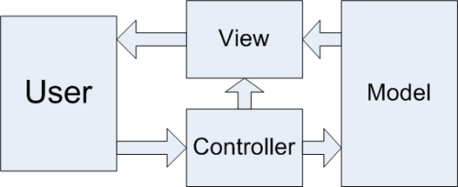
Database
Sends HTTP Request

Model-View-Controller architecture is very useful for interactive web - applications/portals.

MVC design pattern allows to the user to make the application modules to be loosely coupled thus making the code more flexible when the client requires to add few more functionalities to the existing application.

MVC allows introducing the changes to the user interface without affecting data handling mechanism. Even it allows the data to get reorganized without demanding for any change to the user interface.

Architecture reduces the coupling between business logic and data presentation to end user. This model divides into three layers:

1. Model: Contains the business logics and functions that manipulate the business data. It provides updated information to view domain and also gives response to query. And the controller can access the functionality which is encapsulated in the model.

2. View: View is responsible for presentation aspect of application according to the model data and also responsible to forward query response to the controller.

3. Controller: Controller accepts and intercepts user requests and controls the business objects to fulfill these requests. An application has one controller for related functionality.

System Architecture
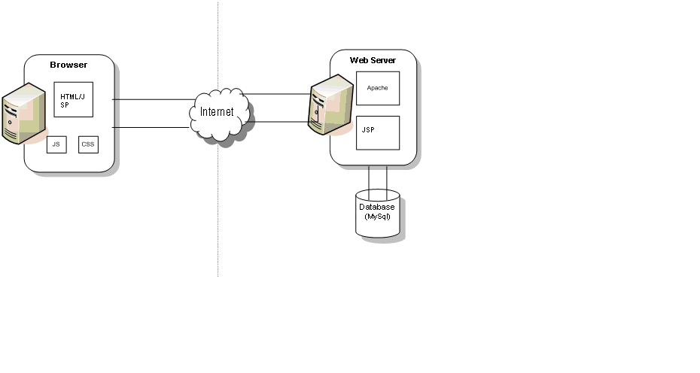

Rich Internet Application - Basics
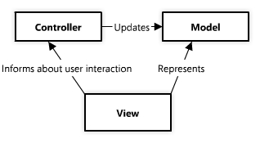
In the web application, the Model is the data source, the Controller is in web server (Apache), and the View is the client.
Rich Internet Applications (RIA) is a web application that has the features and functionality of traditional desktop applications. RIA typically transfers the processing necessary for the user interface to the web client but keeps the bulk of the data (i.e. maintaining the state of the program, the data etc) back on the application server.
We extensively use AJAX to develop such highly interactive and a rich user interface. RIAs can be used to develop new applications that seem impossible with traditional web technologies; they can be used to simplify complex processes like registration, online shopping and data analysis. RIAs can be effectively used to provide an engaging and interactive experience to customers or managers. RIAs can also be made to work with existing web application infrastructure and small modules can be deployed even as part of normal HTML pages.
Here are the some of the main advantages for good architecture matters in RIA development;
  - Consistency
  - Team working
  - Maintainability
  - Code Reuse
  - Flexibility.

Work flows in MGMS:

Role based user access flow
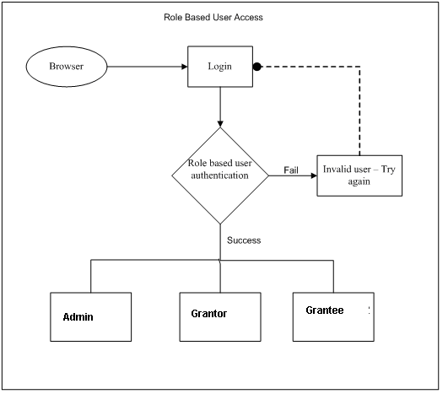

Admin Work Flow
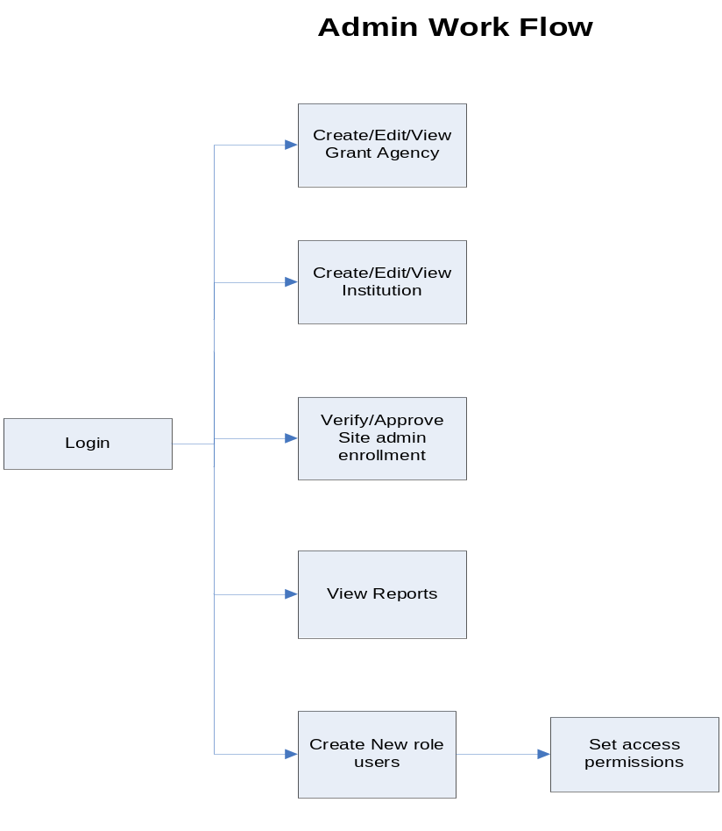

Grantee Work Flow

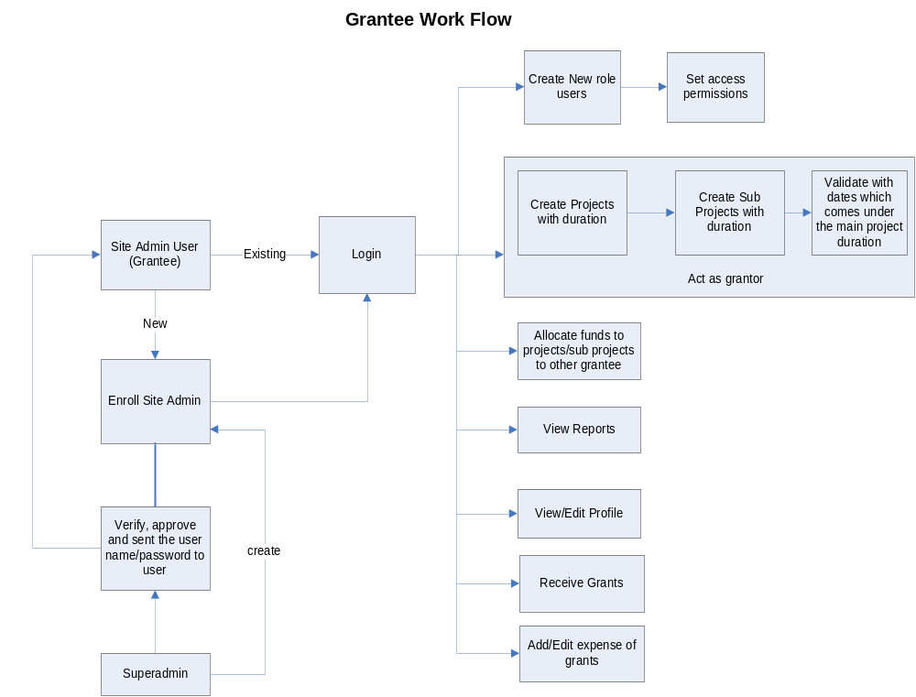

Grantor Work Flow

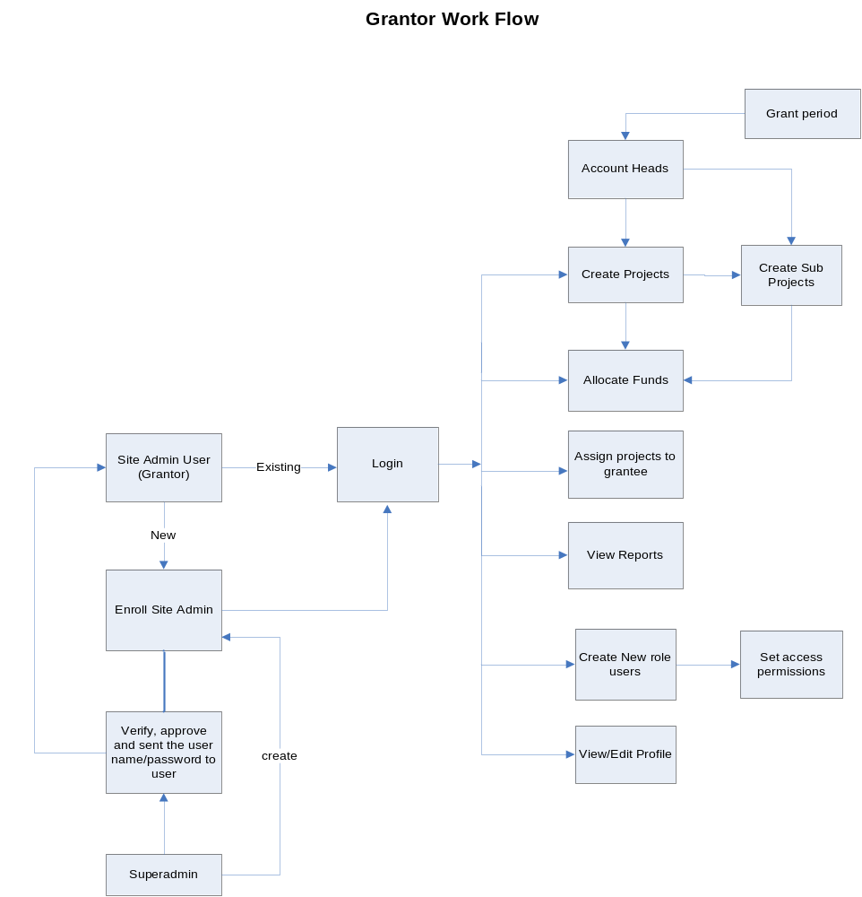

Architecture of MGMS
MGMS is built up on Groovy on Grails frame work. MySql data base is used as backend tool.For graphical dispaly Google Chart is also Used

Groovy on Grails
Grails is an advanced and innovative open source web application platform that delivers new levels of developer productivity by applying principles like Convention over Configuration. Grails helps development teams embrace agile methodologies, deliver quality applications in reduced amounts of time, and focus on what really matters: creating high quality, easy to use applications that delight users. Grails naturally complements Java application development since it is built on Spring and based on Groovy, the leading dynamic language for the Java platform.
Groovy is the leading open source dynamic language for the Java Virtual Machine that offers a flexible Java-like syntax that most Java developers can learn in matter of hours. Groovy provides features seen in other dynamic languages like Ruby, Python or Smalltalk. Groovy really shines in its ability to easily define internal Domain Specific Languages (DSLs) that can be used as an abstraction layer that enables non-technical subject matter experts to codify business rules.
The combination of Groovy and Grails offers productivity benefits rivaling Ruby on Rails, but on the proven, scalable, and seamlessly integrated Java platform. SpringSource offers a support subscription for Groovy and Grails that provides the expert developer and production support, and legal indemnification businesses need to confidently deploy Groovy and Grails technologies across the enterprise.
Figure 1: Extjs/Grails based RIA high level architecture
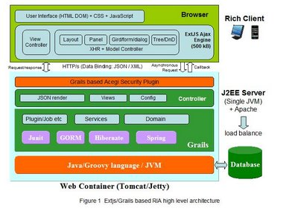

Other technologies:

Grails is an open-source web application framework that leverages the Groovy language and complements Java Web development. Grails is licensed under the liberal Apache 2.0 Software License. The following are the plug-ins being used in conjunction with Grails during the development of MGMS.

- Grails Audit-logging 0.5.3

The Audit Logging plugin can add Hibernate Events based Audit Logging to a Grails project.
It can also add support to domain models for hooking into the Hibernate events system. The Audit Logging Plugin provides tracking of database data changes on a row and column level. The development of this plugin was inspired by the needs of DBAs to be able to reconstruct data level changes over time.

- Calendar-1.2.0 – snapshot 2

Calendar Plugin is a lightweight, customizable and cross platform date picker.
It's based on jscalendar, and doesn't have any dependence with external JavaScript library.
It provides a tag library to include date picker in your pages, and allow select date and time values easily.

Two new features have been added to grails calendar plugin for 1.2.0 version, they are:
- Option to clear date.
- When using time, calendar closes after select date.

- Eastwood-chart-0.5

The latest version of the eastwood-chart plugin (0.5) depends on Google chart plugin version 0.5.0
Features:
  - Emulates Google Chart using JFreeChart
  - Simple and easy usage using API that's similar to Google Chart
  - Supports pie charts, bar charts, line charts and scatter plots

- Fckeditor-0.9.5

This is a Grails plug-in for using FCK editor rich editing features in a Grails application. CK Editor (formerly FCK editor) is an open source WYSIWYG text editor from CKSource that can be used in web pages. It aims to be lightweight and requires no client-side installation. Its core code is written in JavaScript, having server side interfaces with Active-FoxPro, ASP, ASP.NET, ColdFusion, Java, JavaScript, Lasso, Perl, PHP and Python.

- Google-chart-0.5.0

The Google Chart API lets you dynamically generate charts with a URL string. You can embed these charts on your web page, or download the image for local or offline use.
- A rich gallery of visualizations provided as:
  - Image charts - using a simple URL request to a Google chart server
  - Interactive charts - using a Google developed JavaScript library
- Can read live data from a variety of data sources
- Enable adding live charts to any web page.

- Hibernate-1.2.3

This is a plug-in that provides integration between Grails and Hibernate through GORM. The Hibernate Events plugin adds support to domain models for hooking into the Hibernate event system using the following methods: afterInsert, afterUpdate, afterDelete, beforeLoad, afterLoad, beforeSave, and afterSave. The plugin uses a hibernate.cfg.xml file to declare the event listener, because it is the only way currently to participate in the construction of the hibernate sessionFactory.

- Jasper-0.9

This plugin allows integrating reports Jasper reports into your Grails application. This allows you to export data from your DBS to a number of different file formats. Currently the following formats are supported:
- PDF
- HTML
- XML
- CSV
- XLS
- RTF
- TEXT
- ODT
- ODS
- DOCX
- XLSX
- PPTX

- Jquery-1.4.2.5

This is a cross-browser JavaScript library designed to simplify the client-side scripting of HTML. Jquery is a fast and concise JavaScript Library that simplifies HTML document traversing, event handling, animating, and Ajax interactions for rapid web development.

- Mail-0.9

The mail plug-in provides e-mail sending capabilities to a Grails application by configuring a Spring MailSender based on sensible defaults. The mail plug-in provides a MailService that can be used anywhere in your Grails application. The MailService provides a single method called sendMail that takes a closure. In addition the sendMail method is injected into all controllers to simplify access.

- Modalbox-0.4

ModalBox is a JavaScript technique for creating modern (Web 2.0-style) modal dialogs or even wizards (sequences of dialogs) without using conventional popups and page reloads. It's inspired by Mac OS X modal dialogs. And yes, it may also be useful for showing larger versions of images.

JQuery modalBox is a simple jQuery plugin that provides a multiple customizable modal dialog. This plugin is written in JavaScript on top of the jQuery library and shows inline content, content served through AJAX and single images.

- Spring-security-acl-0.2

The ACL plugin adds Domain Object Security support to a Grails application that uses Spring Security. It depends on the plugin. The core plugin and other extension plugins support restricting access to URLs via rules that include checking a user's authentication status, roles, etc. and the ACL plugin extends this by adding support for restricting access to individual domain class instances.

- Spring-security-core-0.4.1

The core provides the basics necessary for access control in an easy-to-use package based on users and roles. here are also several extension plugins that depend on the core plugin and extend it by adding functionality. These include:
  - Spring Security OpenID which adds support for OpenID authentication
  - Spring Security ACL which adds support for object-level and method-level authorization using ACLs
  - Spring Security CAS which adds support for single sign-on using Jasig CAS
  - Spring Security LDAP which adds support for LDAP and ActiveDirectory authentication
  - Spring Security UI which provides CRUD screens and other user management workflows.

- RichUI 0.8

This plugin adds a set of AJAX components which can be used to create rich user interfaces without having to deal with JavaScript libraries. Some of these components require JavaScript libraries or CSS. RichUI contains all these libraries like YUI etc. so the developer does not have to download them separately. It uses a renderer concept where each component is rendered by a dedicated renderer.

- ckEditor 3.4.2.0

CKEditor is a text editor to be used inside web pages. It's a WYSIWYG editor, which means that the text being edited on it looks as similar as possible to the results users have when publishing it. It's a component to be used by developers to enhance their applications. CKEditor inherits the quality and strong features people were used to find in FCKeditor, in a much more modern product, added by dozens of new benefits, like accessibility and ultimate performance.

- Grails Tomcat-1.2.3

This plugin replaces Jetty with Tomcat as the default development time server for Grails. The regular Grails commands like run-app etc. will operate against Tomcat instead of Jetty. No other installation of an external Tomcat distribution is required.

